**Deployment of MenuItemListing**

**step 1: Create a Kubernetes Cluster**

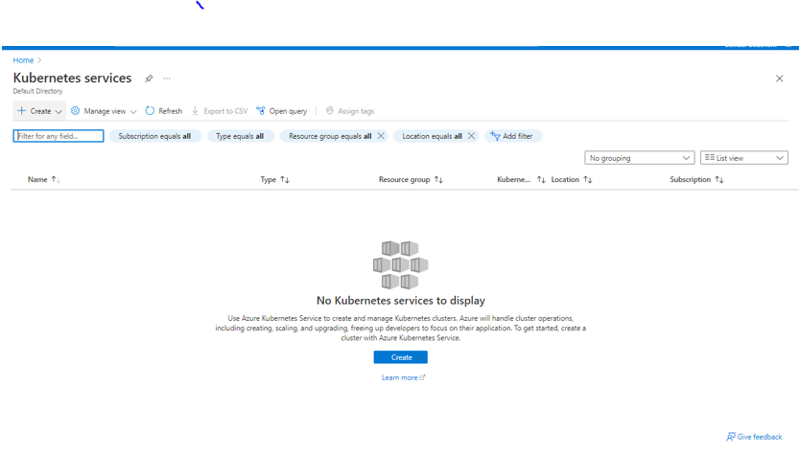

**Step 2: Give all the Required Details**

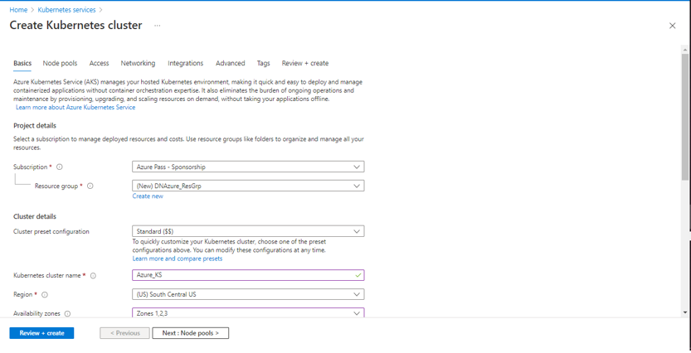

**Step 3: Choose the Container Registry in Integrations part**

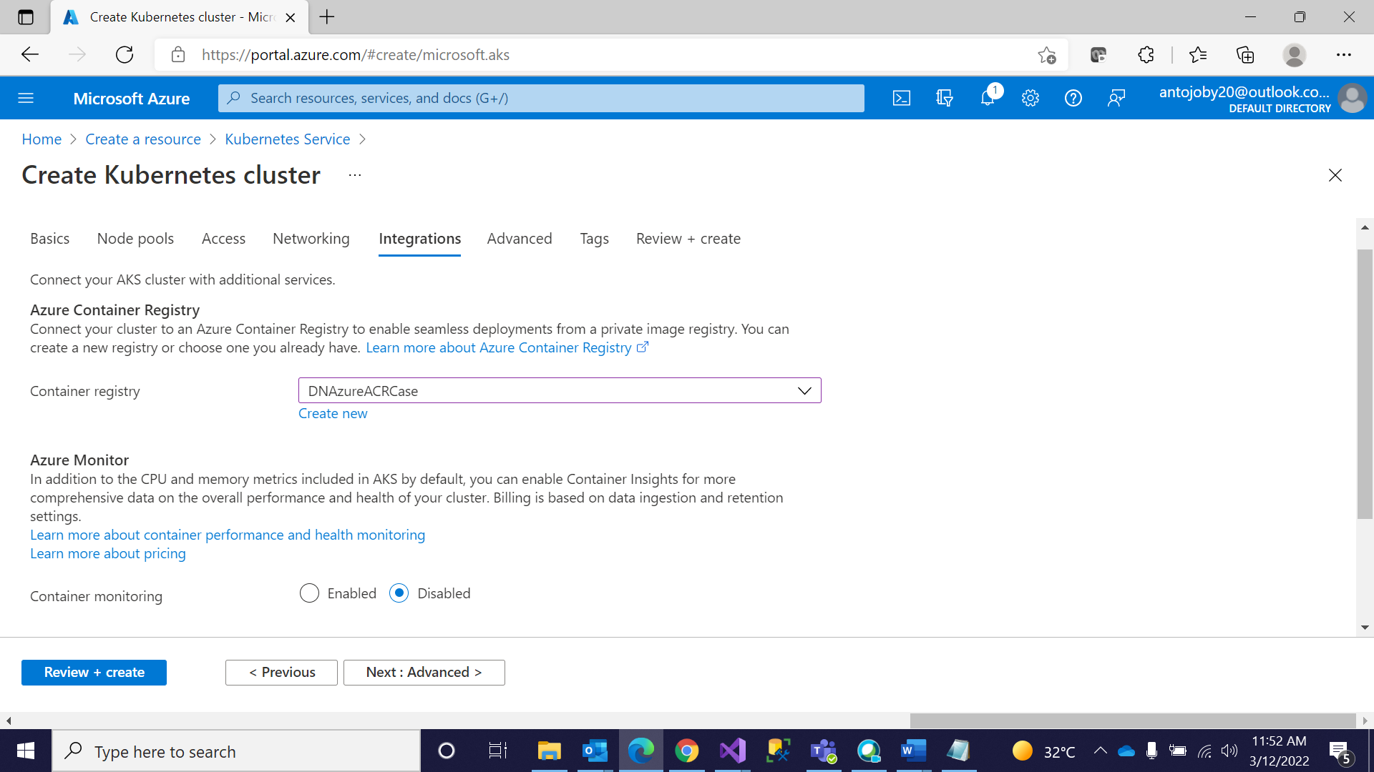

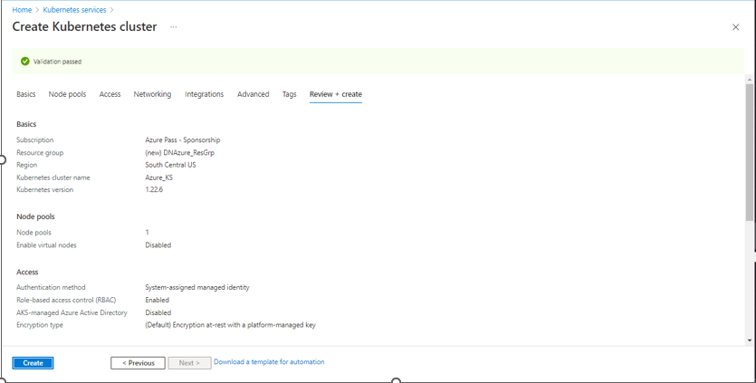

**Step 4: After Deployment go to resources**

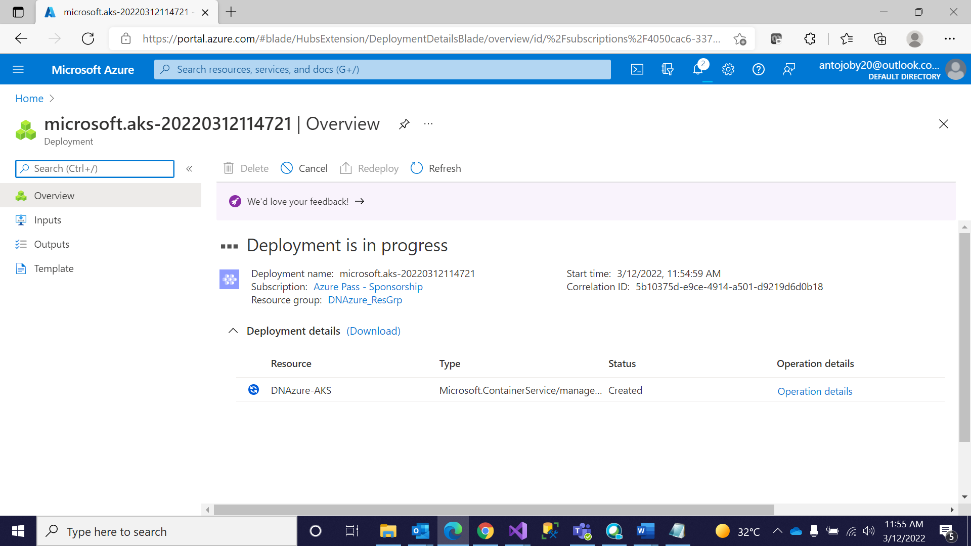

**Step 5: Open Cloud Shell and Create the Secret Key**

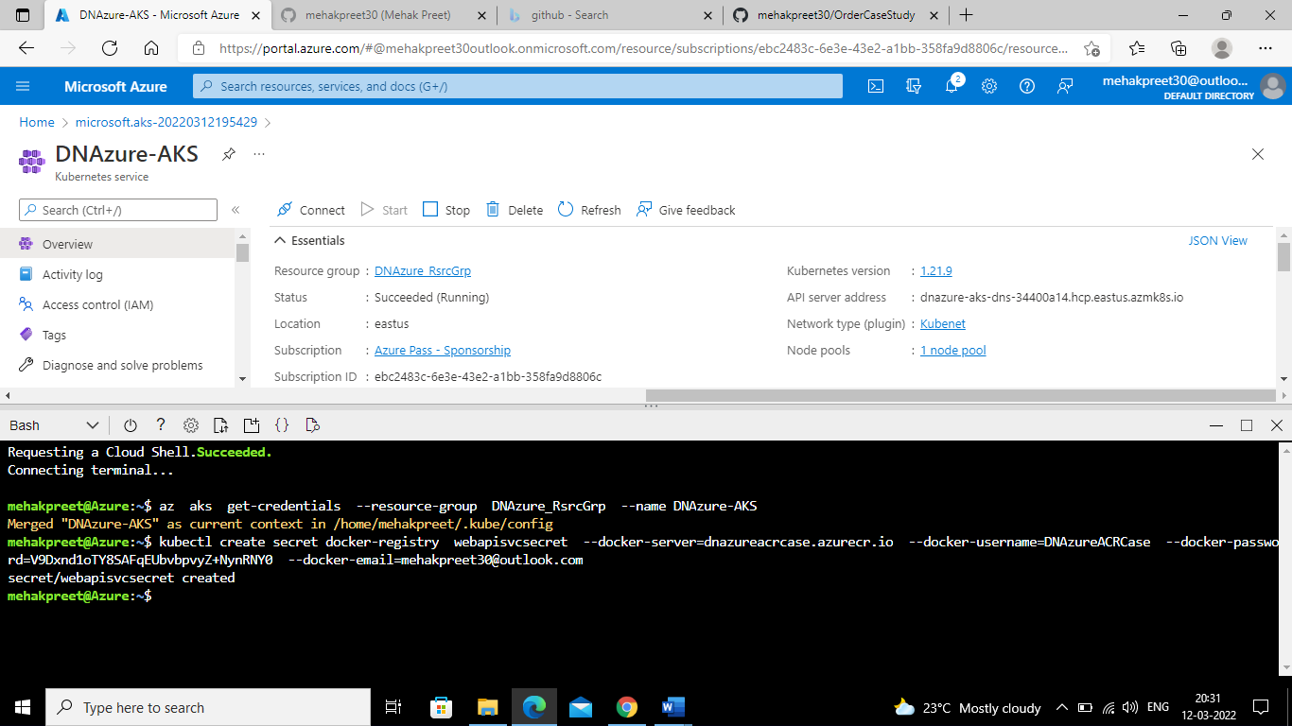

**Step 6: Add Yaml File in the Project and Deploy it in the Cloud and After Build go to CI Pipeline**

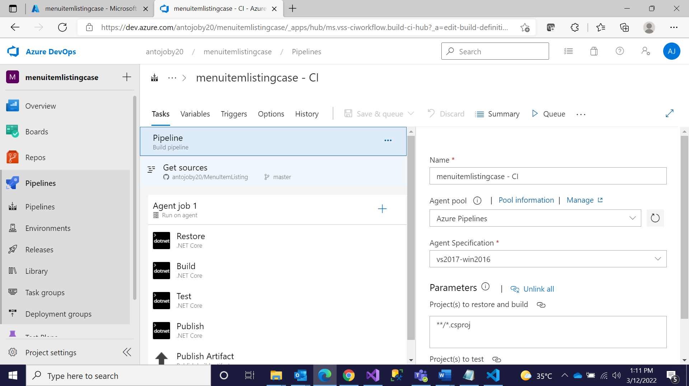

**Step 7:Click on Docker (Already Added during Initial Deployment)**

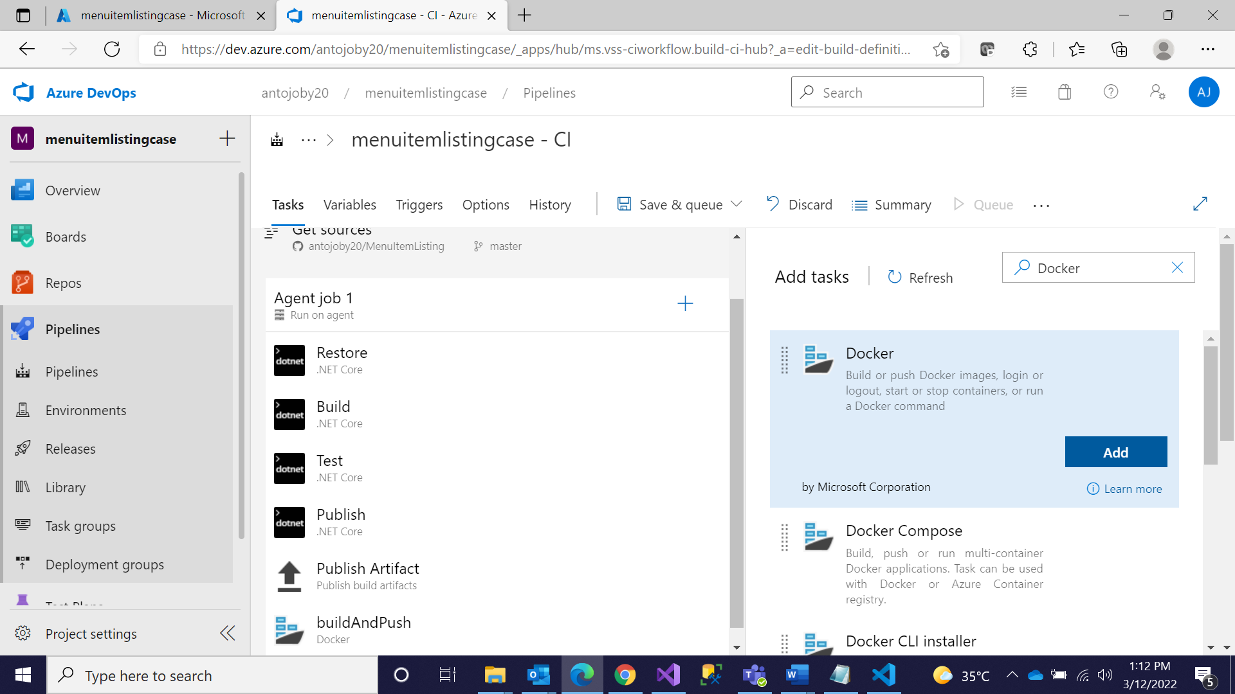

**Step 8: In tags type latest**

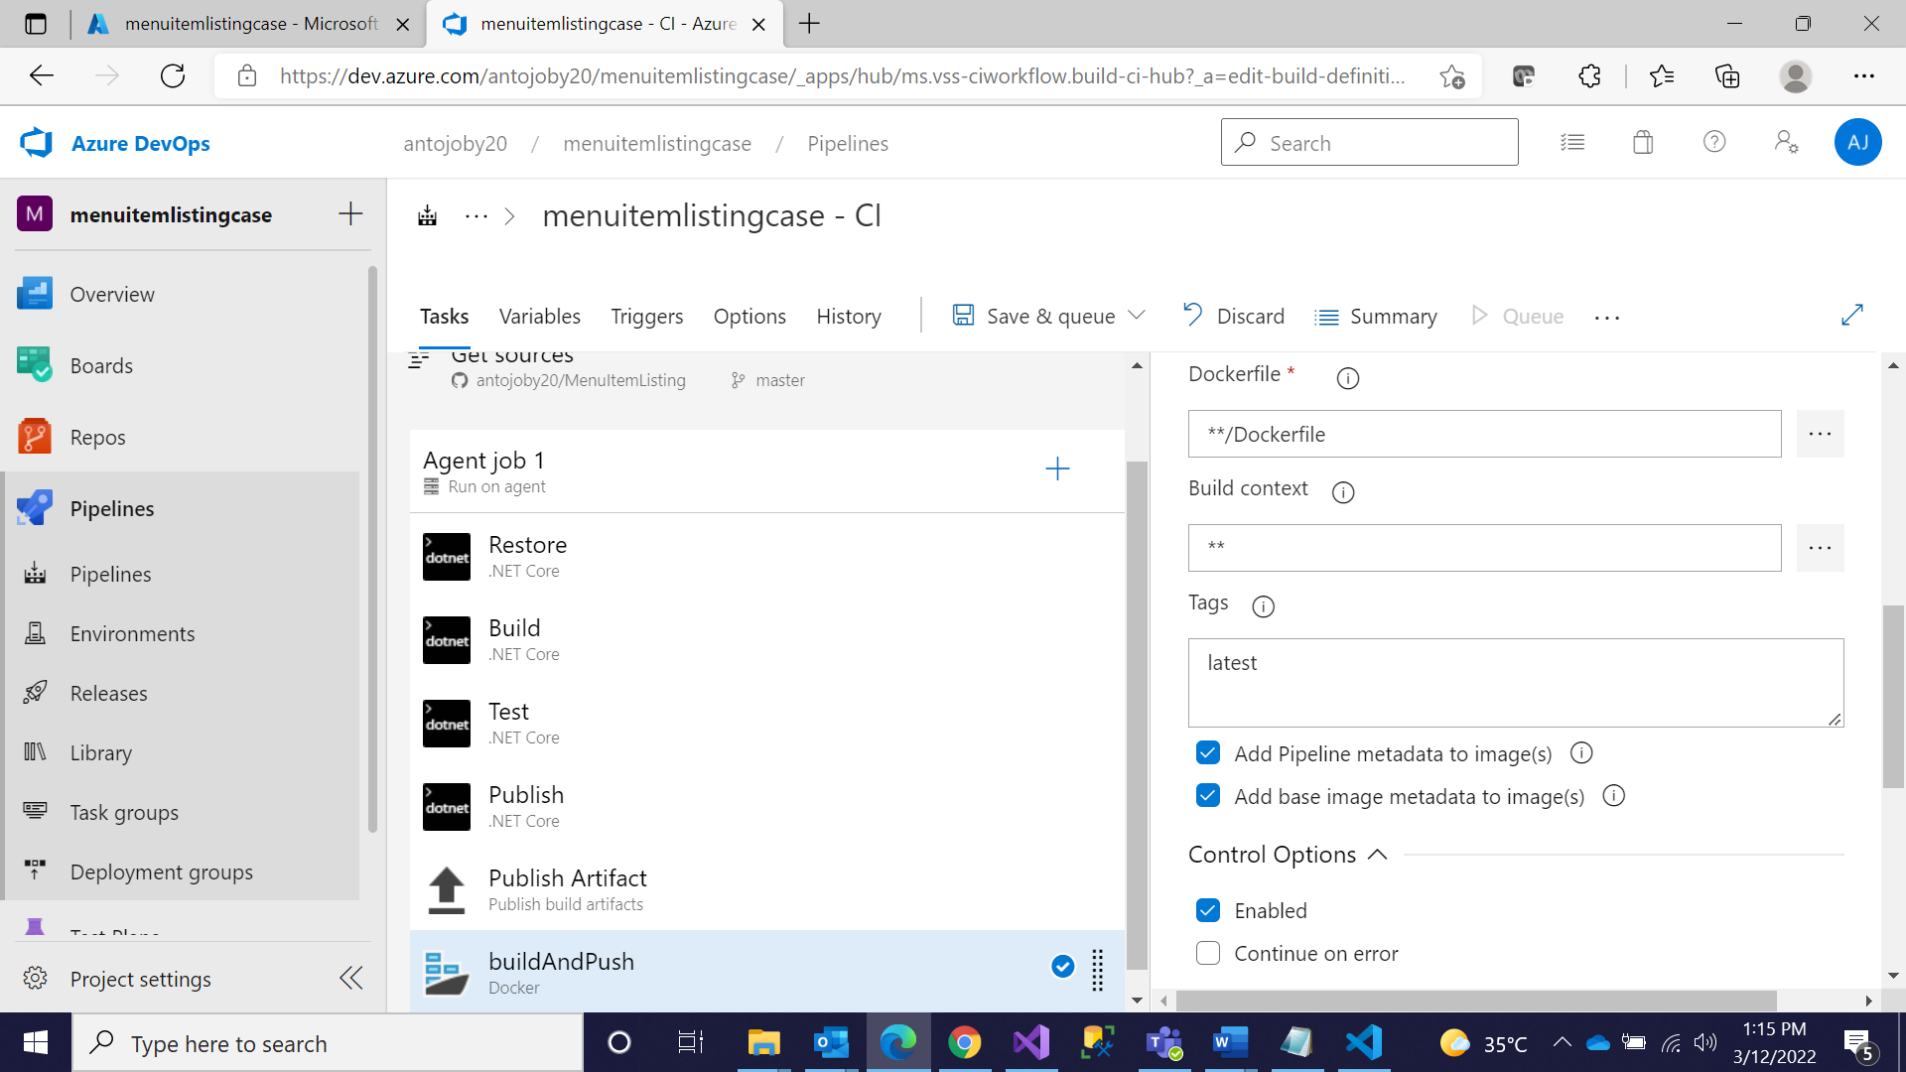

**Step 9: Uncheck Zip in Publish and Save**

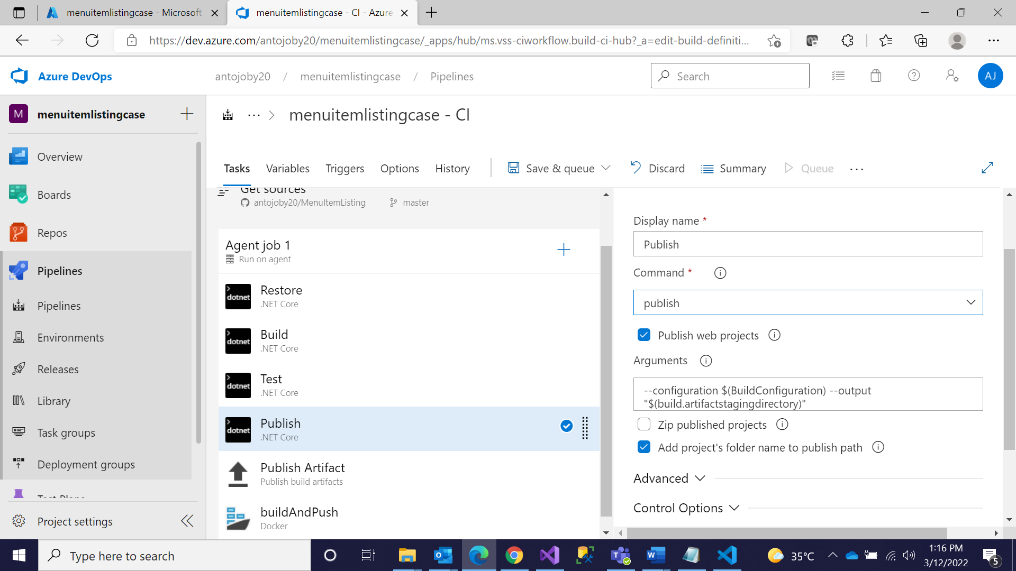

**Step 10: Go to CD pipeline and Edit**

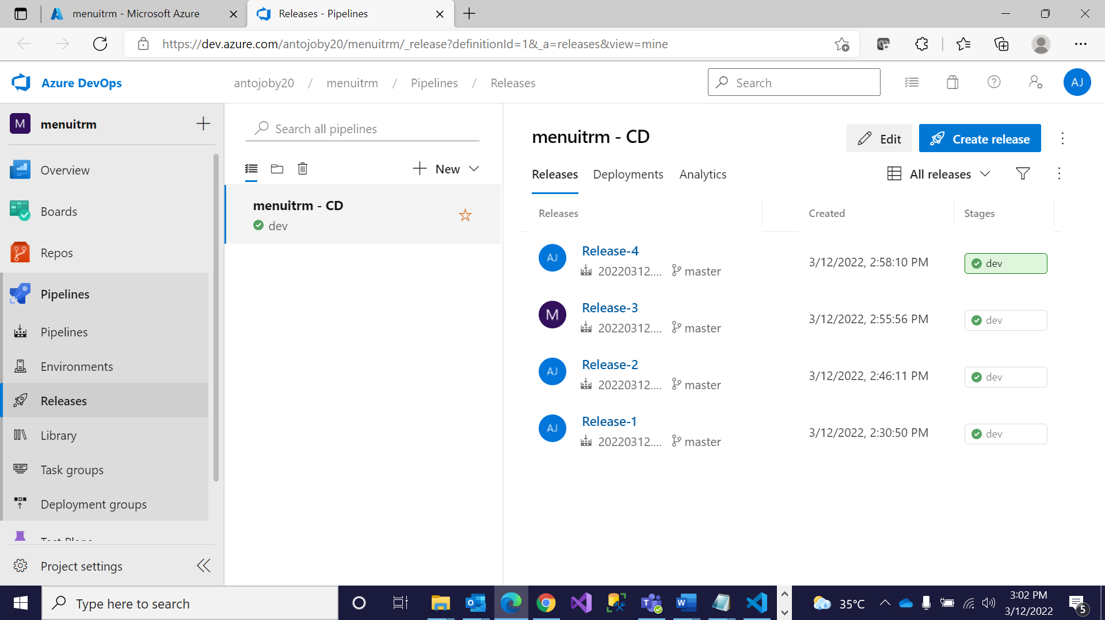

**Step 11: Disable both the Tasks**

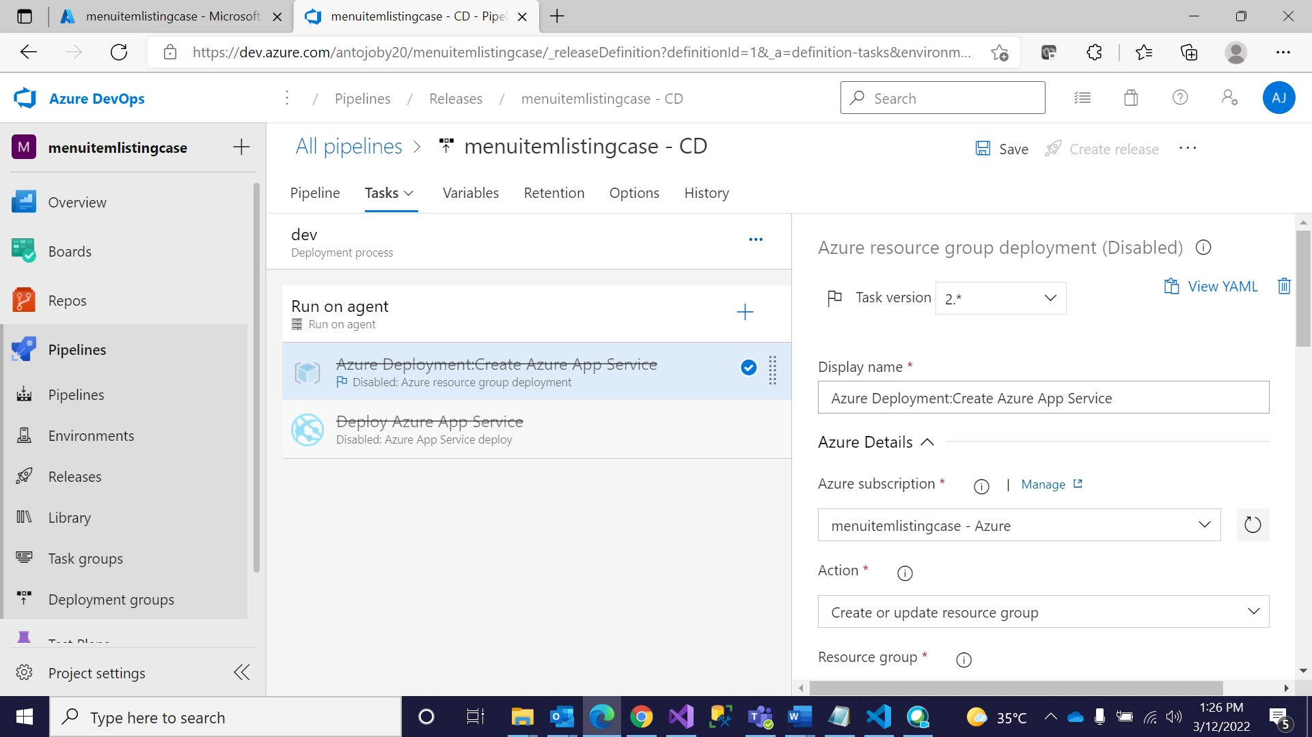

**Step 12: Add kubectl**

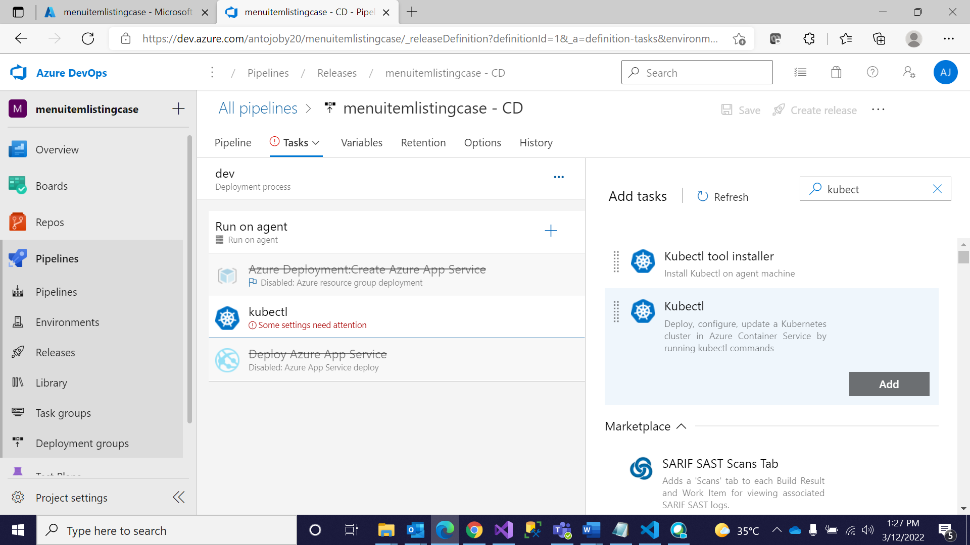

**Step 13: Give all the Details**

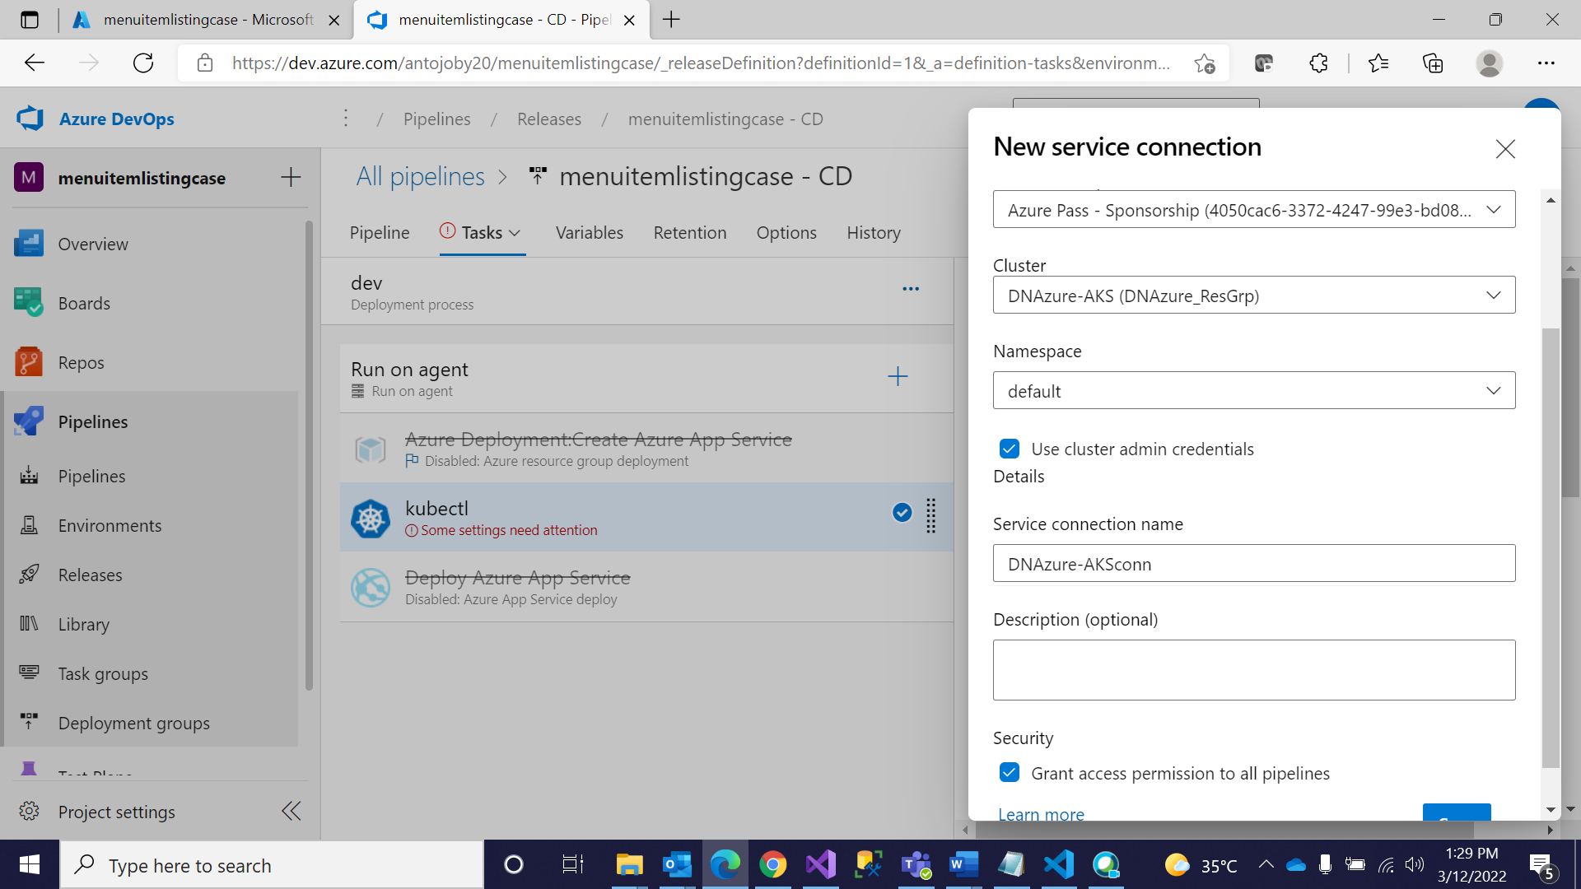

**Step 14: Give the Configuration and add yaml File**

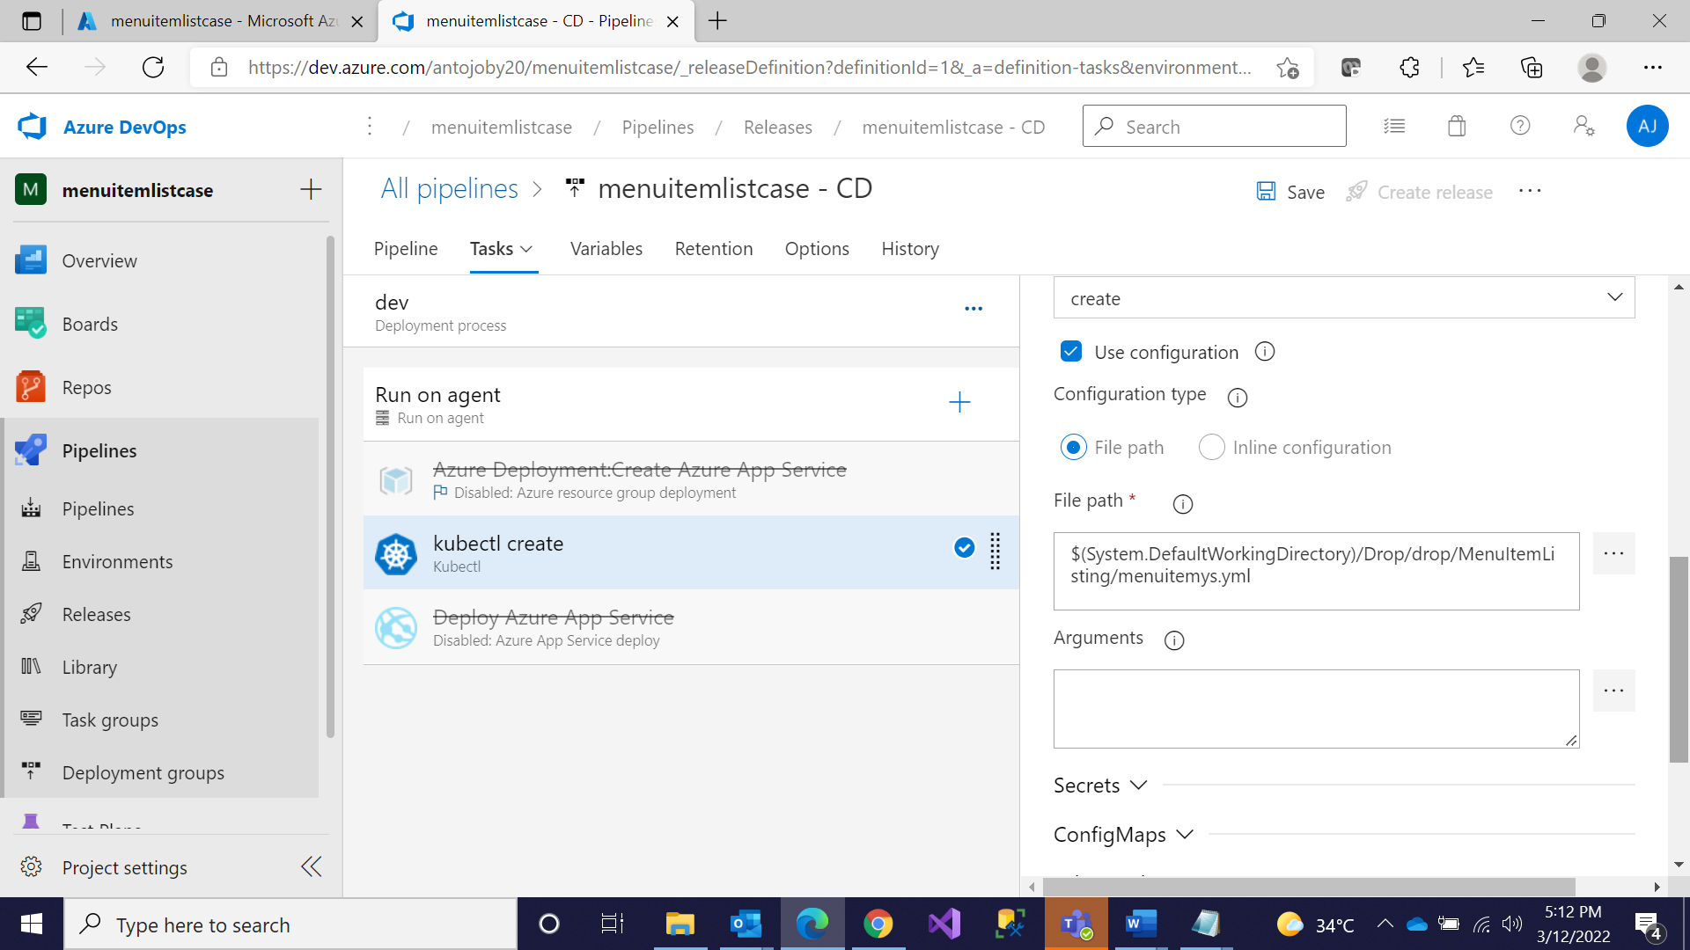

**Step 15: Give the Secret key ,Save and Create a Release**

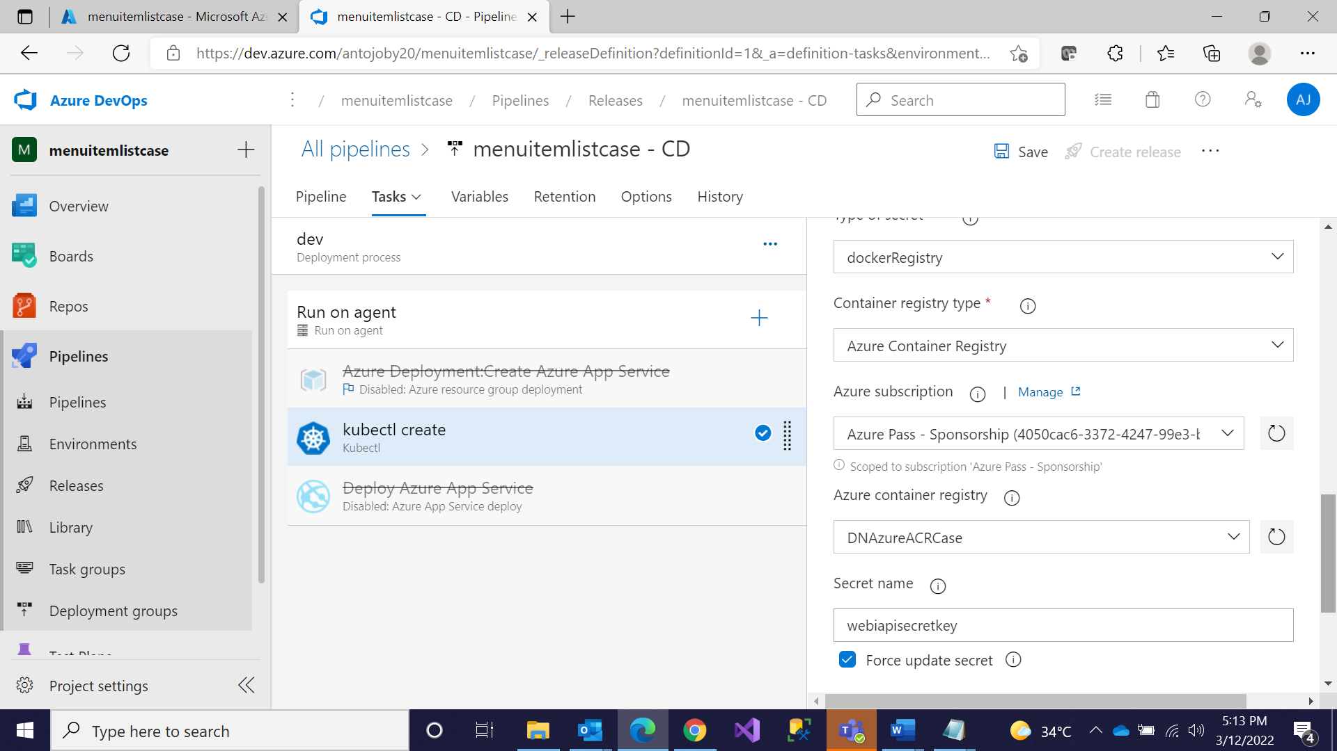

**Step 16: Go to Kubernetes Cluster and Click on Workloads**

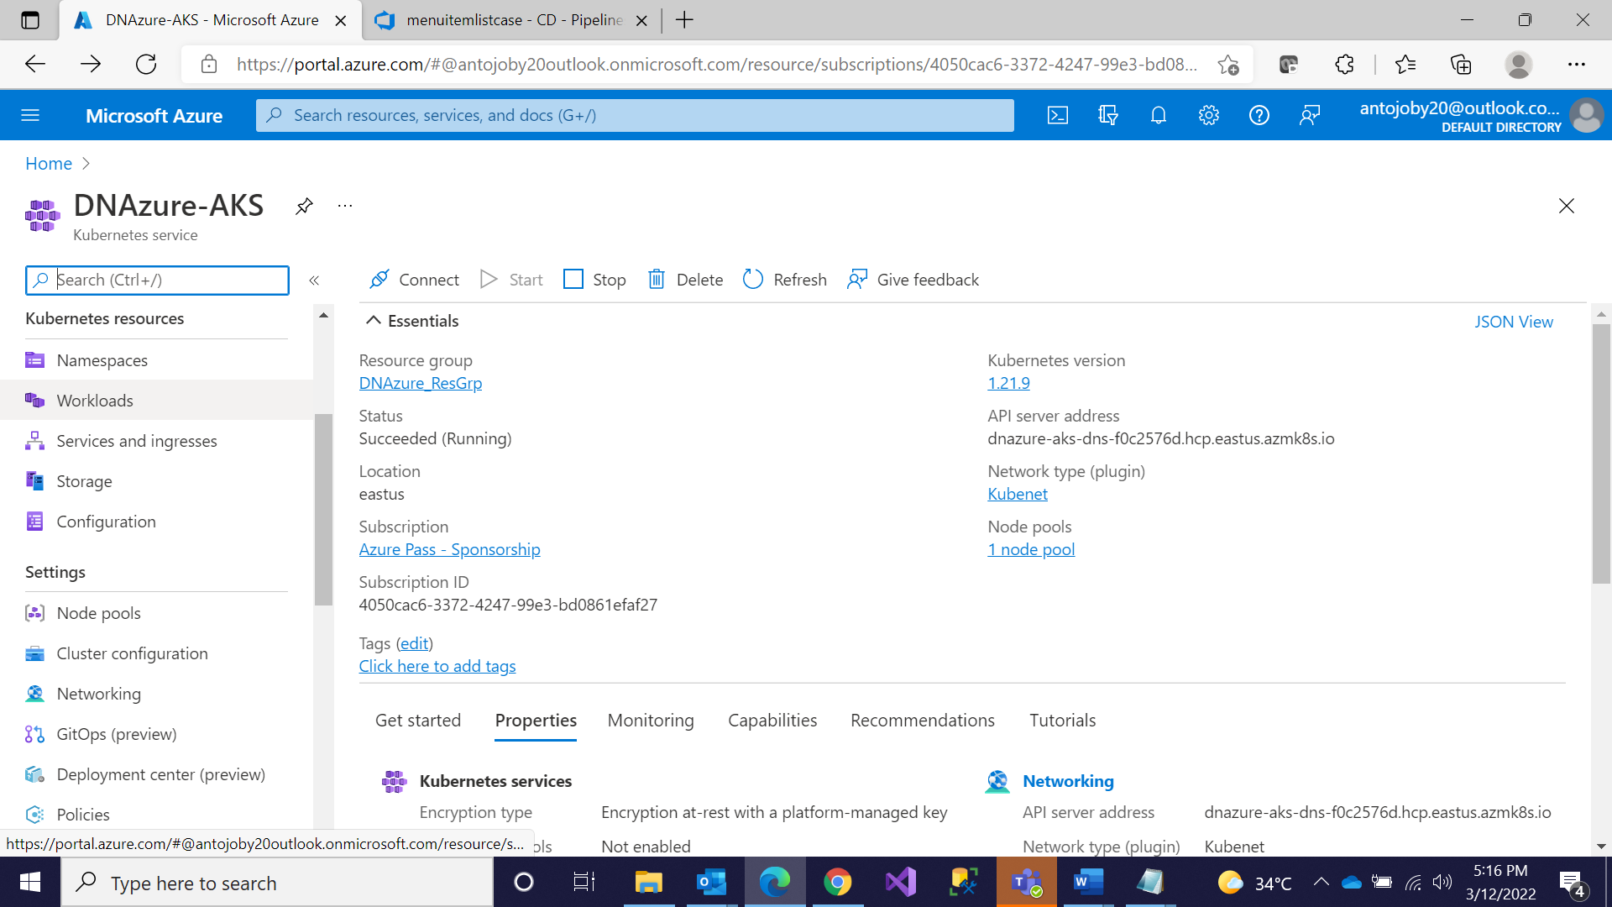

**Step 17: Successfully Deployed**

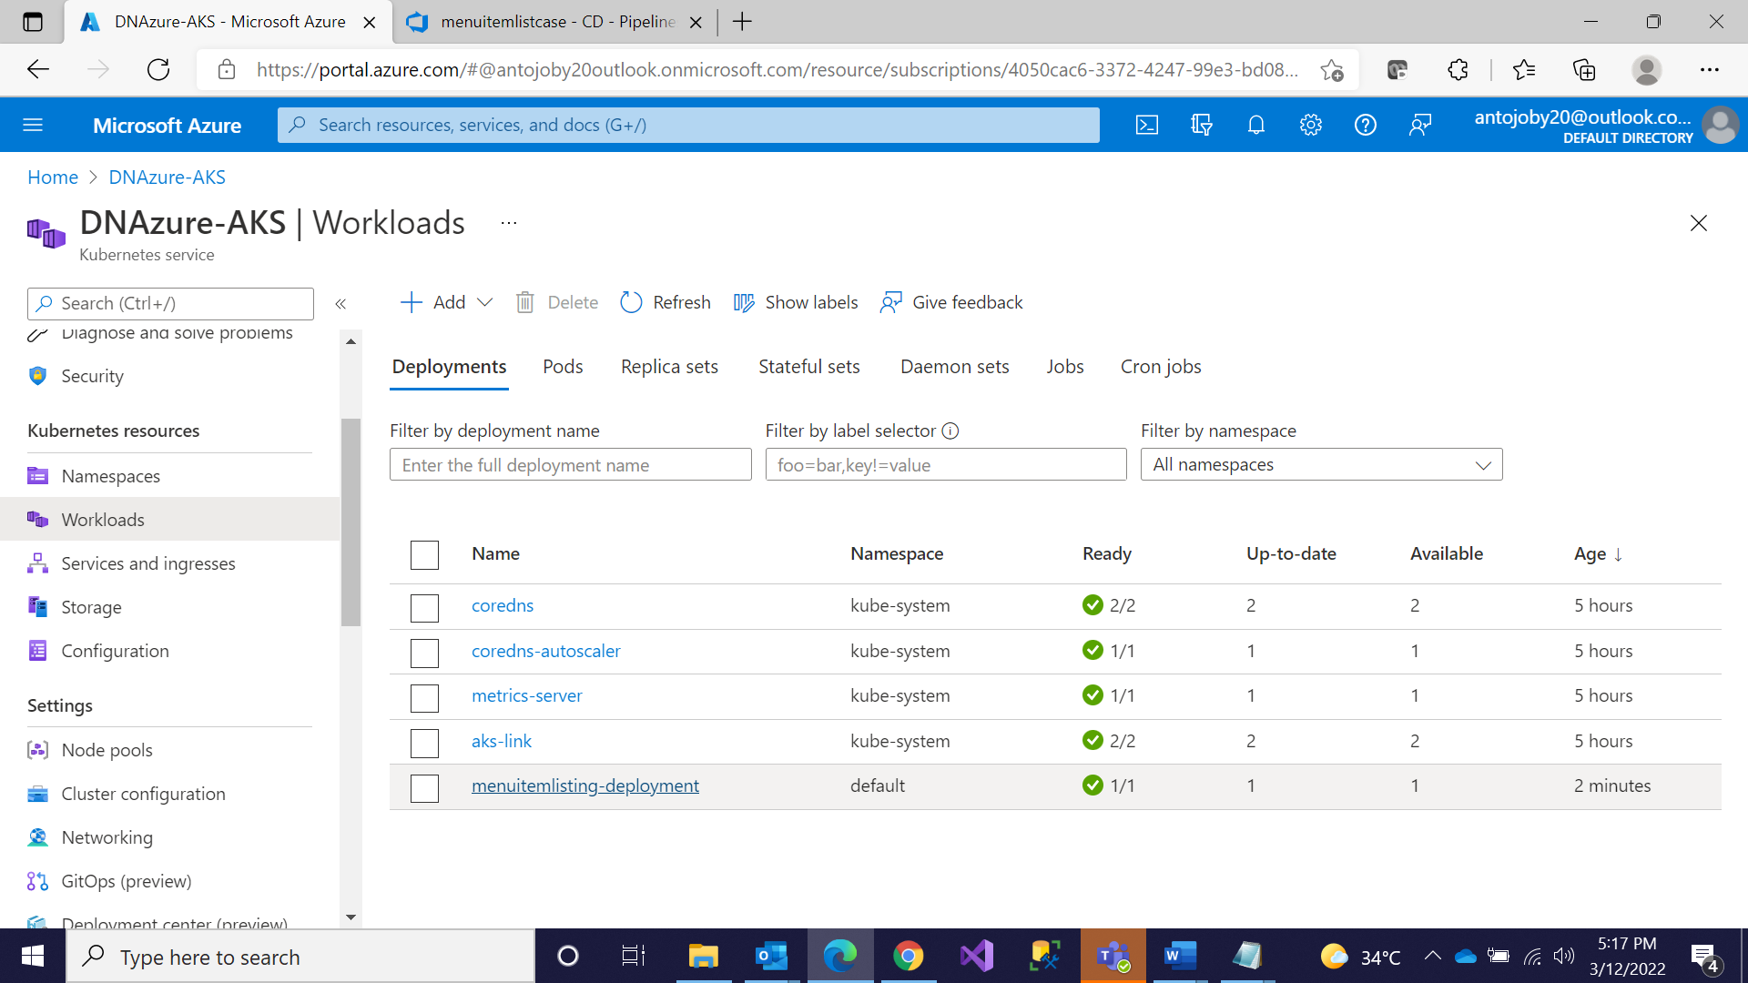

**Step 18: Go to Services and Ingresses and Click on the IP and Give Api/Controllername**

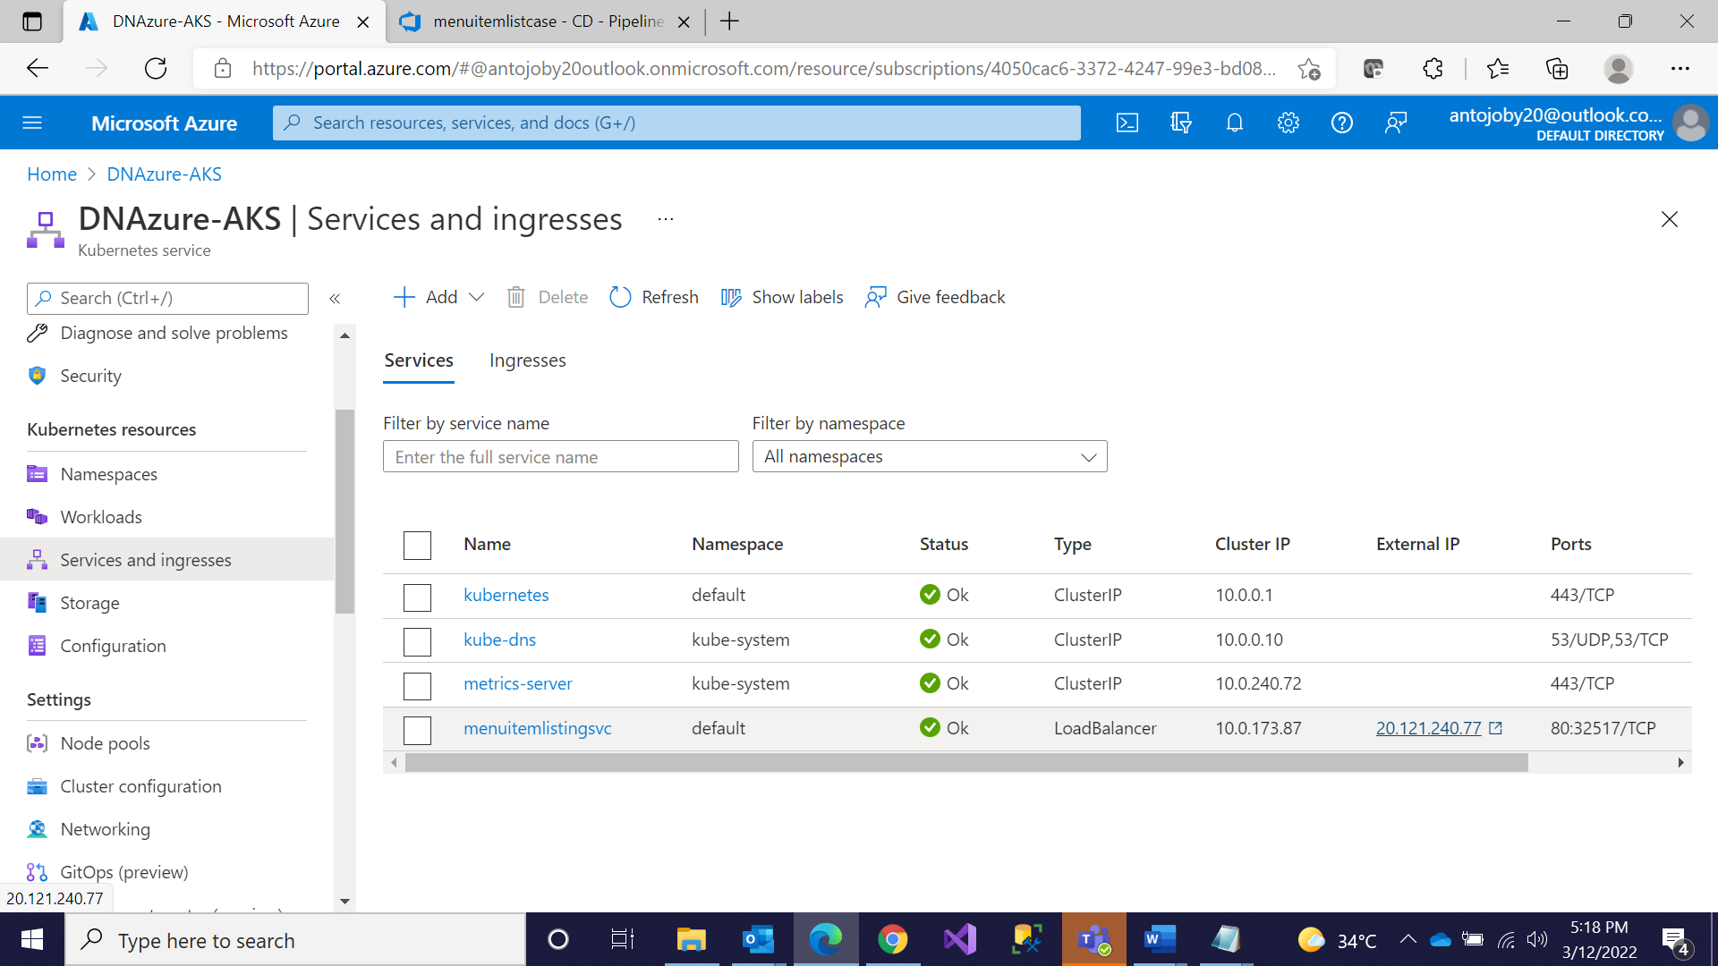

**Step 19: Successfully Deployed**

